## Reflections Vol I Nov 11-Sep 13.pdf - Page 1

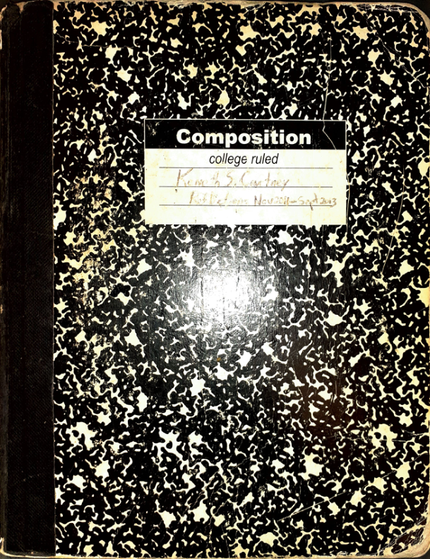

No text found for this image.

## Reflections Vol I Nov 11-Sep 13.pdf - Page 2

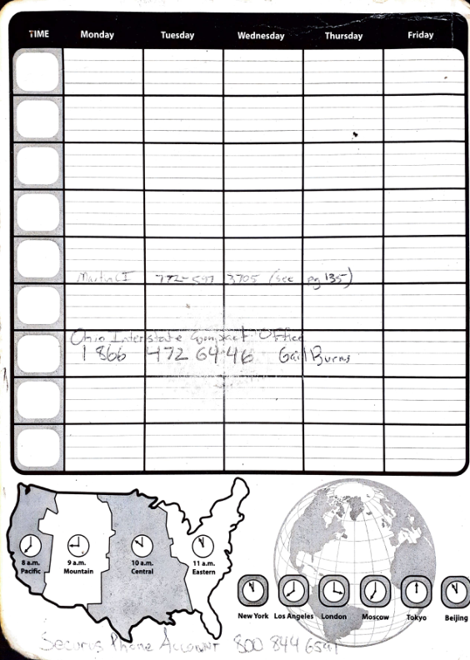

No text found for this image.

## Reflections Vol I Nov 11-Sep 13.pdf - Page 3

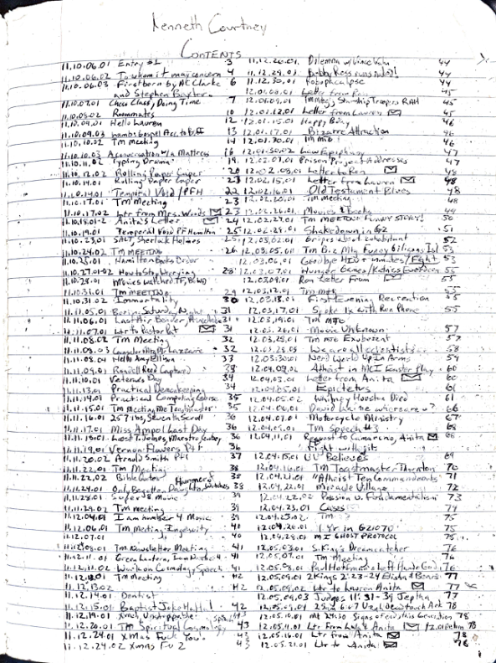

No text found for this image.

## Reflections Vol I Nov 11-Sep 13.pdf - Page 4

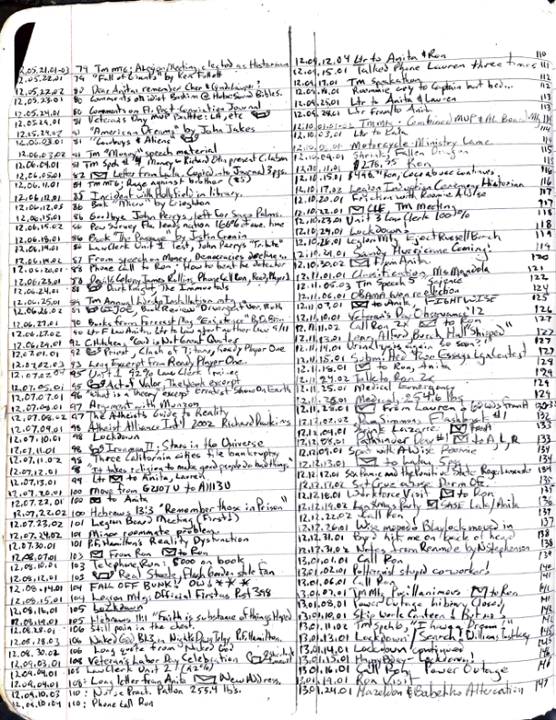

No text found for this image.

## Reflections Vol I Nov 11-Sep 13.pdf - Page 5

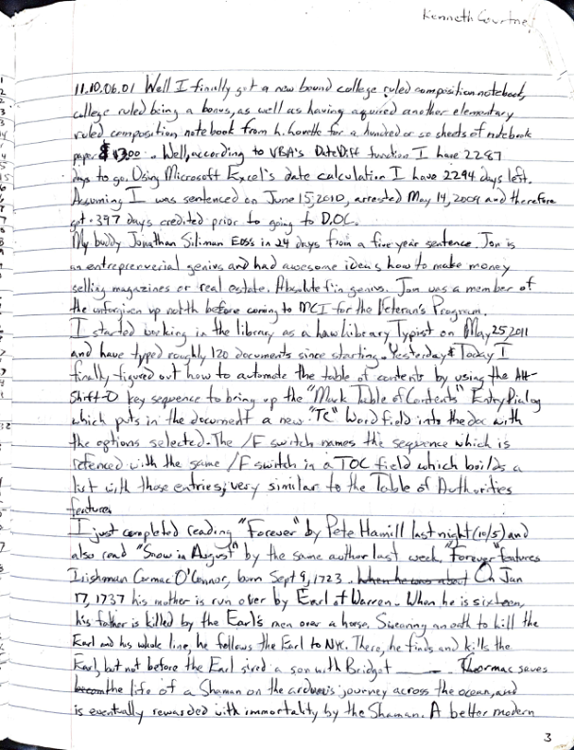

No text found for this image.

## Reflections Vol I Nov 11-Sep 13.pdf - Page 6

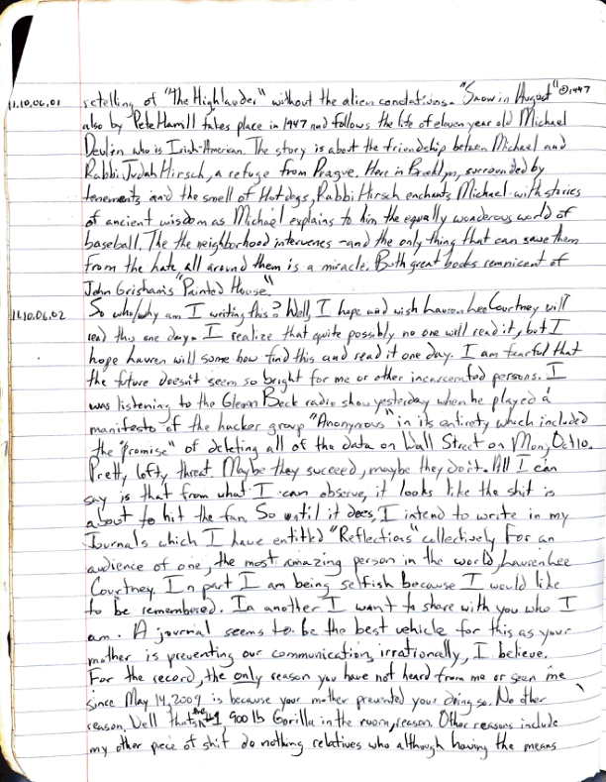

No text found for this image.

## Reflections Vol I Nov 11-Sep 13.pdf - Page 7

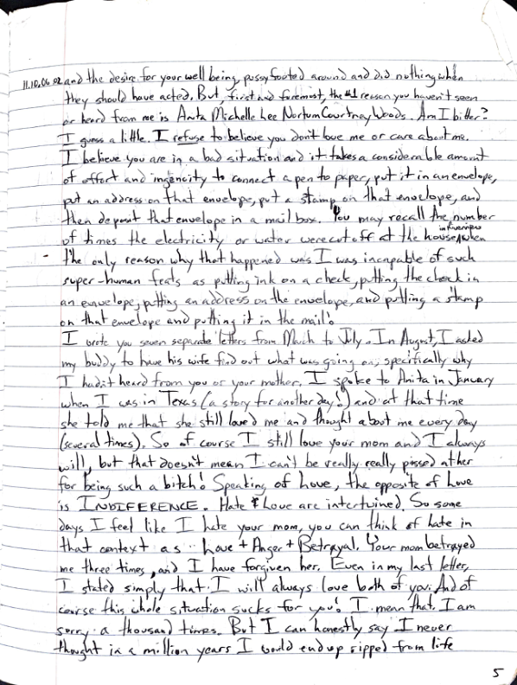

No text found for this image.

## Reflections Vol I Nov 11-Sep 13.pdf - Page 8

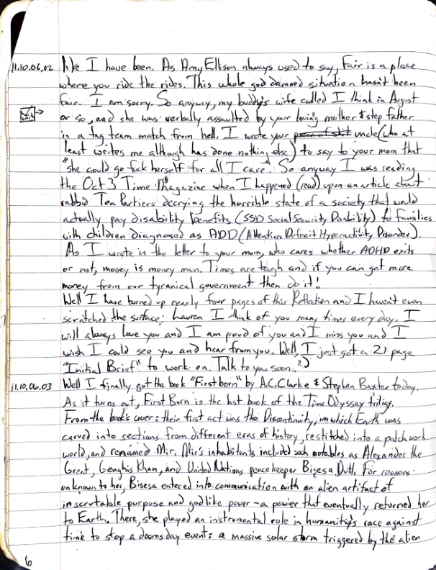

No text found for this image.

## Reflections Vol I Nov 11-Sep 13.pdf - Page 9

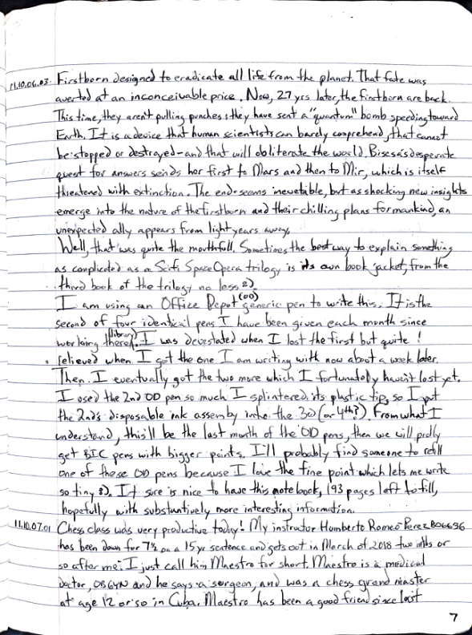

No text found for this image.

## Reflections Vol I Nov 11-Sep 13.pdf - Page 10

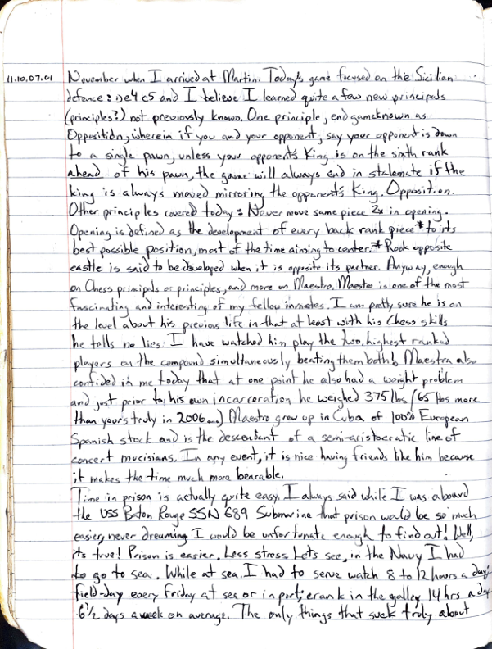

No text found for this image.